**Introduction**

**AWS Elastic Beanstalk**

1. AWS Elastic Beanstalk provides an environment for deploying and scaling web applications.
2. An environment is a collection of AWS resources, such as EC2 instances, a load balancer, and an Auto Scaling group, that are used to run an application.
3. Elastic Beanstalk supports multiple environments for an application, such as development, staging, and production.
4. Each environment can have different configurations, such as instance types, load balancer settings, and security groups.
5. Elastic Beanstalk provides various pre-configured platforms to deploy applications, such as Java, .NET, Node.js, Python, Ruby, and Docker.
6. Elastic Beanstalk can automatically provision and configure the necessary AWS resources, such as EC2 instances, security groups, and load balancers, based on the selected platform and environment configuration.

**Architecture Diagram**

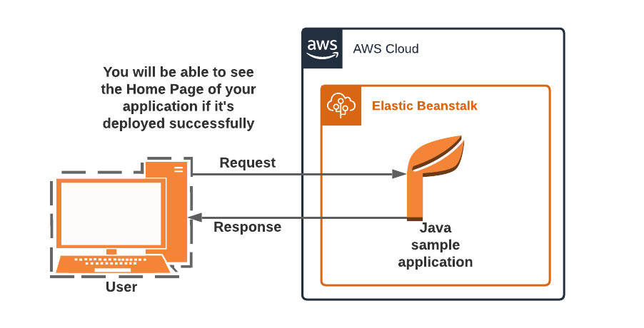

# ****Lab Steps****

## ****Task 1: Sign in to AWS Management Console****

1. Click on the **Open Console** button, and you will get redirected to AWS Console in a new browser tab.
2. On the AWS sign-in page,
   * Leave the Account ID as default. Never edit/remove the 12-digit Account ID present in the AWS Console. Otherwise, you cannot proceed with the lab.
   * Now copy your **Username** and **Password** in the Lab Console to the **IAM Username and Password** in AWS Console and click on the **Sign-in** button.
3. Once Signed In to the AWS Management Console, make the default AWS Region as **US East (N. Virginia) us-east-1.**

## ****Task 2: Create your first Elastic Beanstalk Application****

In this task, you will learn how to navigate to Elastic Beanstalk and create a new environment with specific configurations.

1. Navigate to Elastic Beanstalk by clicking on the **Services** menu in the top, then click on Elastic Beanstalk in the Compute section.
2. Once Elastic Beanstalk is opened, you’ll be presented with a getting started screen. Click on the **Create application**
3. In **Configure environment**page :
   * Environment tier : Select **Web server environment**
   * Application Name: Enter **Sample_Application**
   * Note: This is usually the name of the product/project that you are building.

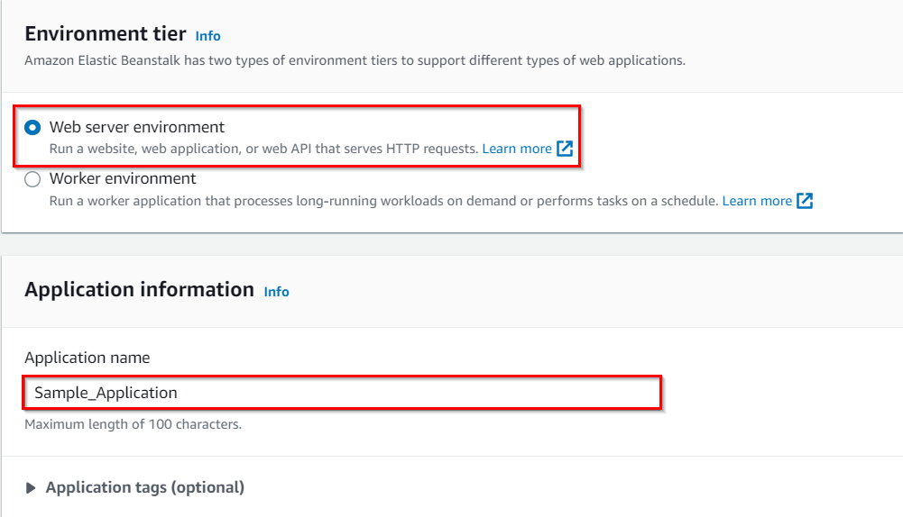

* + Under Platform: Choose**Java** and leave other options as default

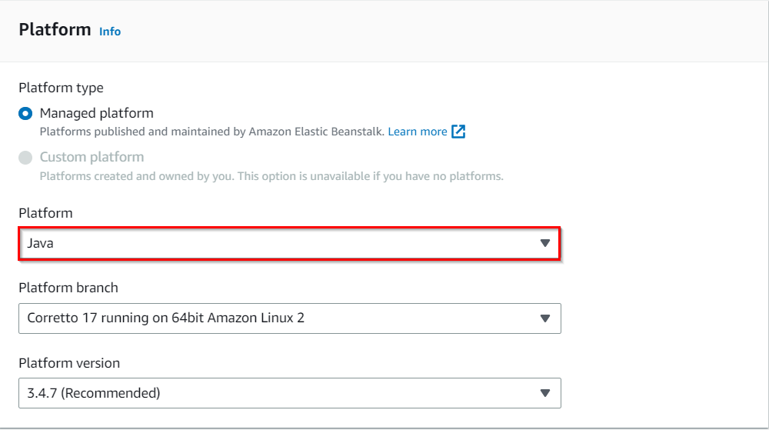

1. Scroll down and click on the **Next** button.
2. In **Configure service access** :
   * Service role : Select **Create and use new service role**
   * EC2 Instance profile : Select **EC2_Role**

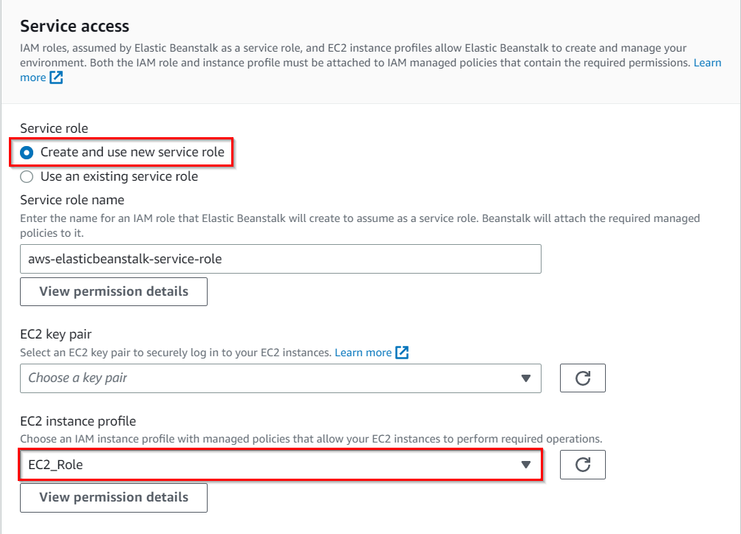

1. Keep things as default and click on **Next** button.
2. To **Set up networking, database, and tags** :
   * VPC : Select **Default** VPC
   * **Check** the **Public IP address**checkbox
   * **Check**the **us-east-1a** and **us-east-1b** subnets checkbox under **Instance subnets**.



1. Keep rest things ad default and Click on **Next**button.
2. To **Configure instance traffic and scaling** :
   * Scroll Down to capacity section and Under**Instance Types**, **remove the existing instance types**and select **t2.micro** from the drop-down.



1. Click on **Next** button
2. In **Configuring updates, monitoring, and logging** :
   * Scroll down to **Managed platform updates** section.
   * **Uncheck** the Managed updated checkbox



1. Keep things as default and click on **Next**button.
2. Review the details and click on **Submit** button
3. Once the above is completed, you will be able to see **SampleApplication** in the dashboard. This is the main Elastic Beanstalk screen for your application. A sample screenshot is given below:
4. On the dashboard, you can see your application URL.
   * ***Sampleapplication-env.mfp5vhxpmt.us-east-1.elasticbeanstalk.com***

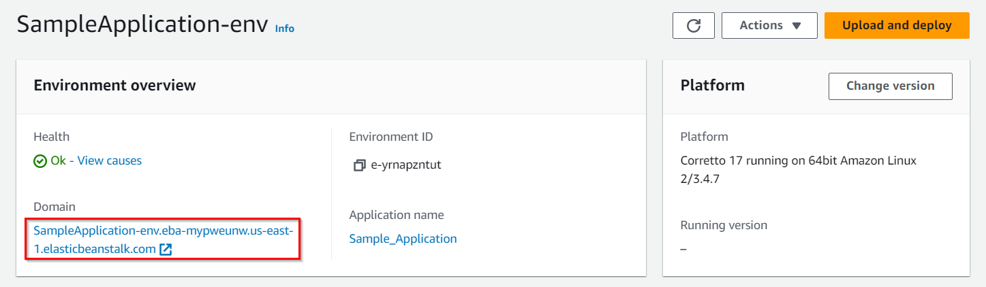

1. To test your application, copy the app URL and paste it into your browser. You will see your application is running successfully. A sample screenshot is given below:

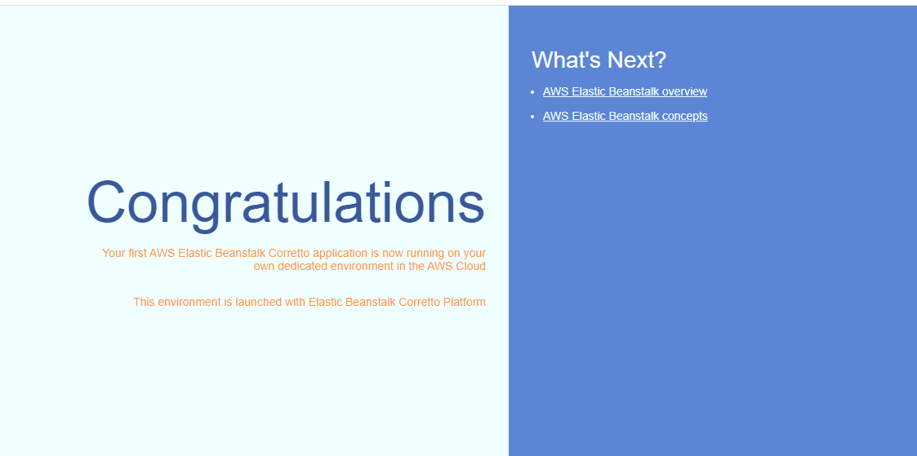

14. You can click on the options given on the page, where they would be redirected to the elastic beanstalk documentation of AWS.

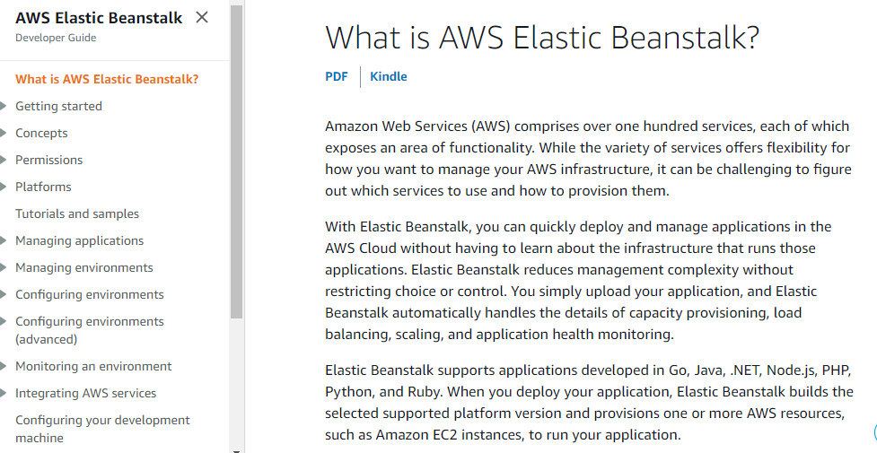

### ****Do You Know?****

**Elastic Beanstalk provides a simple way to deploy and manage applications on AWS, by abstracting away the complexities of infrastructure management. It allows developers to focus on writing code and building features rather than worrying about infrastructure provisioning, scaling, and monitoring.**

## ****Task 3: Validation Test****

1. Once the lab steps are completed, please click on the **Validation** button on the left side panel.
2. This will validate the resources in the AWS account and displays whether you have completed this lab successfully or not.
3. Sample output :

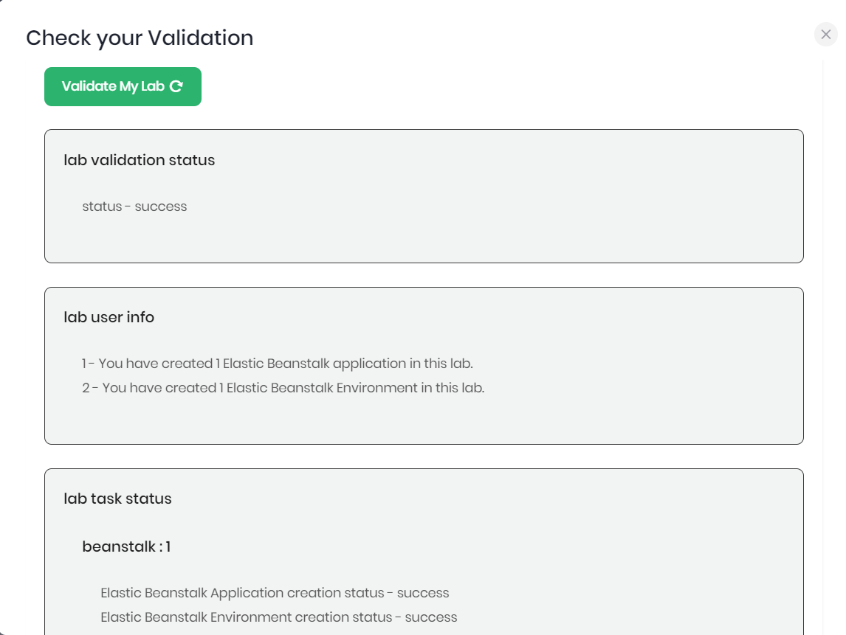

# ****Completion and Conclusion****

1. You have successfully deployed a sample Java Application in AWS Elastic Beanstalk.
2. You have tested the deployed application with the URL generated after the deployment.